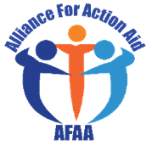

Project title | Integrated Emergency Health Response for flood affected Communities in Payinjiar County.
Final report | March 2022- Feb 2023 final annual report
Country | South Sudan
Due Date | 28.2.2023
location | Majak, Nyal Payam
Contact | Email: allianceforactionaid@gmail. Tel: +211921677846
TABLE OF CONTENTS
- Foreword
- List of Acronyms
- Background
- AFAA Priorities
- AFAA achievement
- Funding needs
- Strengthened leadership, governance, and advocacy for health
- Challenges
- Way forward on common challenges
- Conclusion
- Acknowledgement
- Successful histories

A) FORWARD

Michael Gatluak Tuok-Ex. Director
2022 brought new opportunities by improving lifesaving through mobile healthcare service intervention in Panyijiar county of Unity state, South Sudan by paving the way for much needed healthcare service among the flood affected community in Majak and the surrounding catchment areas and with innovative ideas that highlight the county capabilities and instill hope among its populations.
Despite facing onslaughts such as floods, COVID-19 and insecurity, AFAA through Vitol and the Sagel family foundations support, marched along to ensure high-quality service delivery in Majak and its catchment area are delivery to the fullest. The importance of having willing donors Like Vitol and Sagel family foundations become the quintessential to steering evidence service and decision-making on the most affected areas in the county, the alliance for action aid has supported the county in service delivery, analyzing data, and sharing information through county health department and other reporting channels like the WHO for EWARS, IDSR, DHIS2 and health cluster news bulletin.
Flooding is a critical focus area and it needs the well plan integrate healthcare service to increase access to the most affected community to get adequate healthcare service in the highland they settled, especially the areas where there are no emergency health partner implementing the health programs.
2023-2024, AFAA will focused on issues that have remained in the shadows. For example, Boma health initiative, CEmoNC. The WASH program will be through another partner. The sign of no reduction of water level in the Panyijiar County even during the dry season need more focus and attentions. Despite an absent strategy to mitigate this issue of flood, AFAA through its Vitol and sagel family foundations will update the approach of 2022 to reduce the health gaps in the service delivery.
Also, the new integrated AFAA health model will be the Strategic Plan 2023-2024 that will expand service deliveries to the most needed population cut off by flood from accessing healthcare service. These including those hard-to-reach highland and locations. The service deliveries hard to reach have been achieved through dedicated health staffs and the volunteers as they marched on despite difficulties ranging from insecurity and floods to budgetary limitations. Innovation, inform decision-making, building technical capabilities including the exchange visit plan to DRC will ensure good quality community health services. The plan is on your table as a request and will remain our key focus to achieve our Boma health initiative approach. AFAA will continue to support the population affected by flood through your funding support, a coordination and collaborative approach with other donor/ partners. We thank Vitol and Segal Family Foundations for their support during these flood/ hardships by extending your support to the community of Panyijiar who are in dire needs of health service. On behalf of AFAA team, I’m humbly thank you all for your valuable financial support and skill development contributions. We look forward for your ardent support as we strive to enhance access to health service delivery in Panyijiar and other part of South Sudan in 2023-2024 and beyond. We resolve to uphold and follow the AFAA mission to delivery service and advocate for healthcare service delivery for all.

Thank you very much.

B) LIST OF ACRONYMS

AFAA Alliance for Action Aid
AFP Acute Flaccid Paralysis
ART Antiretroviral Therapy
BeMONC Basic Emergency Obstetrics and Neonatal Care
COVID-19 Coronavirus Disease 2019
DHIS District Health Information Software/system
DR Drug Resistant
EPI Expanded Programs on Immunization
EVD Ebola Virus Disease
Hep Hepatitis
HIV Human Immuno-Deficiency Virus
HRP Humanitarians Response Plan
IARHK Inter-Agency Reproductive Health Kits
IEHK Interagency Emergency Health Kits
IDSR Integrated Disease Surveillance and Response
IMCI Integrated Management of Childhood Illness
IPC Infection Prevention and Control
MoH Ministry of Health
SMoH State ministry of health
NPHL National Public Health Laboratory
PHCU Primary Health Care unit
PPE Personal Protective Equipment
SAM Severe Acute Malnutrition
SC Stabilization Centre
SSHF South Sudan Humanitarian Fund
STI Sexually Transmitted Infections
TB Tuberculosis
UHC Universal Health Coverage
UN United Nations
WBG World Bank Group
WCO WHO Country Office
C) BACK GROUND
Decades of conflicts and flood in South Sudan have undermined the healthcare service performance and capacity to deliver essential health services. Health sector/ institutional are being support by the nongovernmental organization instead of government due to the incapacity of the South Sudan government to delivery healthcare service in the country. However, the overall general service availability score is low at 30.4%, with the health infrastructure and service utilization indices at 43.2% and 15.5%, respectively. The health workforce stock is far below the recommended to attain universal health coverage. As a result, the health sector’s functions are fragmented and not optimally with health sector depending on developmental and emergencies assistance. Over 90% of health service are being supported by the developmental and the emergencies partners. Unity state is on the emergencies spotlight since the beginning of crisis 2013-2016. The situation was also compounded by Covid 19 and the constant flood which engulf almost part of the state in 2020-2022. Unity state is facing multiple challenges emanating from natural disasters, conflicts, and insecurity that profoundly affect the healthcare service performance and overall progress space. Communicable diseases, such as Malaria, pneumonia, diarrheas constitute a significant public health concern. Non-Communicable diseases are on the rise, while mental health disorders significantly affect the population in emergencies humanitarian settings. However, coverage and utilization of essential interventions for women, children and adolescents’ health remain low. Despite efforts, communicable disease tracking and access to basic health care services still remain the big challenge due to the heavy flood in the state. The increase in morbidity and mortality rate due to flood and water vector borne diseases is the health concern in Panyijiar county, with the shifting of the Health Pool Fund funding to world bank funding has create the health gap. The new implementing world bank funding partner still have not start the implementation which now increases high morbidity and mortality rate in the county because the service we offer as AFAA does not meet the complicated cases like the case that need surgery which cannot be handle at the mobile site. AFAA out patient’s consultation is currently on average of 1000 Malaria cases per month at the mobile health site, based on our data collection. Malaria is the leading death in children under 5 years of age. Due to the worsening situation in Payinjiar, UNOCHA classified Panyijiar as IPC4 which prompted Health Cluster to recommended AFAA to run the primary Health Care unit through the supported from South Sudan humanitarian fund (SSHF) in Tiam of Nyal Payam, Panyijiar county. The 2023-2024 Plan support from the Vitol and Segal Family Foundations, AFAA is going to establish Primary Health Care Unit (PHCU), Mobile outreach and the Boma health initiative to save the life of the flood affected population. The poor access to health care facility due to the distance and water level which cut off some of the communities who are living in highland course lack of utilization of preventive and curative basic health and nutrition services thus increase the Malaria and malnutrition rate among children and will be reduce through the implementation of the BHI initiative. The child morbidity and mortality rate being the highest in Panyijiar County, with high deaths per 100 / live births due to obstructed/prolonged labor and lack of skill birth attend. Because of that, most deliveries are being conducted by the traditional birth attendance (TBA) which led to unclean birth deliveries. The low payment of few professional/ midwives includes lack of functional health facilities to conduct deliveries is still being major problem in AFAA mobile site which affected sustainability of the few health professionals/midwives.
D) AFAA PRIORITIES
- AFAA delivered health service to the flood affected community in Majak locality of Nyal Payam, Panyijiar County of unity state and supports the training of the health staff to improve service delivery including data collect, IDRS, EWARS, 5Ws and DHIS2 reporting system.
- Lifesaving interventions such as immunization service delivery, emergency healthcare services, diagnosis and treatment of communicable and non-communicable diseases, and epidemic preparedness and response.
- Reopening of the CEmONC operation theatre to reduce prolonging labor and child and mother death will be minimized.
- Initiating BHI initiative as the way forward to reduce distance cover and increase the utilization of health service in area affected by flood.
- Deploy of the qualified health professional to care curry out curative consultation at the facility level.
E) AFAA ACHIEVEMENT

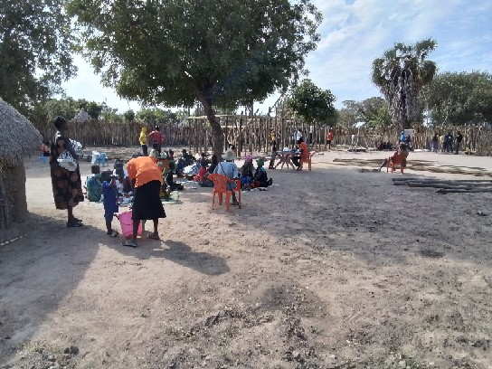
Patients in the queue at Majak mobile site

The mobile outreach intervention project has largely contributed to positive change with life-saving services to flood affected communities in Panyijiar County. Alliance for Action Aid save a total of 28,986 vulnerable population with life-saving health care services including, OPD consultations, immunization, health education, training on IPC, COVID-19, Case Management of Rape (CMR) and MHPSS in majak mobile outreach. 10 Emergency cases management were referred to Ganyiel PHCC for further management because the services are not available at the Nyal PHCC due to absent of health professional from IMC Nyal PHCC. Alliance For Action Aid conducted and agreed to do joint quantitative supportive supervision with county health department in Majak mobile clinic and at any AFAA health facility to ensure the services provided are in line with ministry of health guideline as per the Basic Package of Health and Nutrition Services. During this one-year period, AFAA saved a total of 28,986 vulnerable individuals with Outpatients department (OPD) consultation on curative which divided into three as: IDPS were 10,000 host community being 15,120 and 3,866 were returnees. The mobile outreach project with OPD has achieved indicated result segregation by age male U5 1,985, male above 5 year 2,060, female U5 2,301 and female above 5 years 1, 640 within this one-year period.
The project managed to passed health messages to a total of 7,045 with male being, 2,439, women 2,253, boys 2,353 through community mobilization and health education/promotion. The Community midwife provided antenatal care services to 450 pregnant women and conducted clean deliveries with live births being 187.
10 severe emergency cases were referred to Ganyiel PHCC for further management because the Nyal PHCC is not yet operational due to the shifting of old partner by UNICEF to the new partner which has course health professional gaps. 114 (boys 64 and girls 50) children were vaccinated with Pentavalent which did not reach the projected target in the proposal indicator, because of the shortage of vaccination from county health department through UNICEF supported vaccines. 134 with boys 63 and 71 girls reached with measles antigen vaccinations. AFAA submitted 36 IDSR/EWARS reports to both CHDs and World Health Organization/Health cluster which is in line with South Sudan health system reporting. AFAA managed 3,673 cases of uncomplicated malaria with antimalarial drugs and 6 health workers trained on COVID 19 prevention and control.

F) FUNDING NEEDS
The persistence of floods, poor infrastructure, inadequate funding from other donors and lack of health professional in Panyijiar County will need to request for more funding from the Vitol and the Sagel family foundations to still support the emergency response in Panyijiar County.
The Communicable and non-communicable diseases remain the major contributor to illness and death in Panyijiar especially Malaria, Bhalarzia, Pneumonia and Diarrhea.
More funding is required for strengthening the health staff capacity building, Purchase of antimalarial and other drugs, set up and full instill solar power structure, add additional 1 engine boat and two rowa boats for transportation of referrals of the complicate cases to Ganyliel PHCC or to MSF supporting health facility in Leer, Reopening of the CEmONC that was previously support by CUAMM, hiring the qualified gynecologist that will handle the CEmONC operation theatre.

G) STRENGTHENED AFAA PROGRAMATIC AND ADVOCACY FOR HEALTHCARE SERVICE IN PANYIJIAR

Collaboration is critical to achieving common objectives and goals. It is more important than ever in every changing of context like this one of South Sudan. Partners need to act rapidly and in collaborating manner to address the multiple needs of the state and the county. Any emergencies need to use the resources in an effective and coordinated manner. To this end, 2022 has been an important year from AFAA perspective. Thanks to partners and donor support. AFAA has used their expertise and played a critical role in supporting coordination processes and advancing the health emergency response in Panyijiar County. Critical strives have been made on prevention and disease control, particularly during this flood period and the coordination mechanisms have been essential to achieving common results, the Health Cluster coordination and prioritization of the areas needs emergency response, has been strengthened and add values in the response and ensure that the most pressing needs are met efficiently and effectively. The Joint project in Tiam Locality with Medicair as lead partner on SSHF funding also give AFAA experiences to response and convince other donors for more support and advancing the health advocacy agenda in Panyijiar and other part of South Sudan. AFAA will ensure continuous engagement and dialogue with the other partners through joint efforts and discussions at health cluster and other donor meetings. In order to achieve common goals, AFAA, and other partners will do quarterly assessment to identify the needs and to understand the issues that need to be strategize and address in a coordinated manner.

H) Project indicators and impacts on the project implementation.
- The projected have achieved 28,986 target population that exceeded normal project indicators.
- 61% were pregnant women that attended at least 2 (initial visit + at least 1 follow up visit) during pregnancy
- 7620 attended ANC services from 15-49 years of ages (ANC1, ANC2 and ANC3+)
- 75% women & children <5 that attended and made used of health services (calculated as a percentage of the overall target population)
- Procurement of assorted and essentials drugs supplies and prepositioned them to the project site
- Procured assorted nutrition supplies.
- Procured of assorted WASH supplies
- 61% of births requiring referral that were attended by skilled birth attendance
- 100% mobile clinic clients that report satisfaction with the quality of health services provided
- Nutrition screening by using MUAC for under 5 children, pregnant and lactating mothers.
- 3 community engagement meetings conducted in the project site
- AFAA submitted 36 IDSR/EWARS reports to both CHDs and World Health Organization/Health cluster which is in line with South Sudan health system reporting.
I) CHALLENGE
- In general, more than 60% of the budget was spend on transportation, the purchase of drugs and other medical supplies which led to the low payment of the health staff led to a bundling the mobile outreach by health for better payment from other health partners in the county hinder the service delivery.
- Health service delivery was affected by inaccessibility due to floods, distance cover by footing, poor infrastructure dysfunctional facilities due flood health facility submersion.
- Health coordination at the county level is weak due to shifting of lead partner from IRC to IMC have increase the drugs consumption at AFAA mobile health service intervention.
- Lack of data collection tools undermine tracking progress to achieving the DHIS2 is nascent with lack of data analyses, digital capacity affect data collection and transmission resulting in slow rollout of the data to health cluster.
- Services tend to be provided focusing on the requirements of the donor. This leads to inadequate integration of activities with other public health interventions in many areas of delivery.
- Lack of adequate drugs and commodities to support the implementation of emergencies in Panyijiar.
- Increased malaria morbidity and motility rate under 5 in the area due to lack of mosquito nets for the pregnant mother and children (18 deaths per U5 years).
- Slow implementation of World Bank funding project by the new implementing partner has made service delivery difficult since the number of health staff providing service are few, and there is huge turnout of patients for medical services at AFAA Mobile clinic site.
- Lack of enough AFAA professional health staffs conducting curative consultations for communicable diseases result to heavy work load on ground.
- Long distances coverage by field staff is contributing to inefficient coverage plan per preferred destinations despite the fact that AFAA team used the rowing boat because Islands are far away from Majak mobile base.
- Lack of functioning healthcare facility with delivery and ANC rooms remain a big challenge.
- Capacity gaps is being realise as major problem in health service delivery among the health staff at facility level including training of the monitor and evaluation personal (M&E) to generate the standard reporting tools.
- Lack of engine boat for referrals of the complicated cases to Ganyliel PHCC or to MSF health supported facility in Leer.
J) THE WAY FORWARD ON COMMON CHALLENGES
The AFAA team engaged on partnerships with other partners to leverage their capacities and resources toward addressing the various challenges experienced. By convening and protectively engaging in coordination mechanisms through health cluster and direct engagement with other donors, AFAA will highlight these challenges and lobbied for partners and donors like Vitol Foundation to put more support to mitigate them. AFAA will also engage with the Ministry of Health, state ministry of health and the county health department to enhanced the ownership of programs since all the partners support the government works for good service delivery to the affected population in the county.
K) CONCLUSION
Despite multiple challenges such as flood and budgetary limitations, AFAA will look for partnership with other partners and donors to address the critical health challenges through innovation and adaptability to implement 2023-2024 strategy integrated health model approach. To increasing access to health service through implementation of BHI, more effort on the mobile intervention and used analytics data to drive decisions that will help for future steps and showcased AFAA ability to harness existing strengths. AFAA will review the situation of 2022 and make appropriate measures to learn from the experience. AFA will mainstreaming the mental health needs and child and the mother care into healthcare service to reduce violence in the community, and meet some of the current health demands.
L) ACKNOWLEDGEMENT
We are grateful to our donors for their resilience support, the Ministry of Health for their guidance through WHO and the health cluster, state ministry of health and the county health department and the other Agencies for their support. We work closely to actualize our mission in the state and in the county level. Our work would be incomplete as health team without Team commitment from AFAA leadership, health staff and our donors. The assistance and the guided you give us in every step of the way improved our emergency approaches to fullest. Finally, our partners’ guidance and valuable contributions have helped us to work and inspired us to do more and we hope to have your continuous support every time we need it. Our gratitude goes to:
- Vitol Foundation
- Segal Family Foundation
- South Sudan Humanitarian Fund (SSHF) through Health Custer

K) SUCCESSFUL STORIES
Name: Stephen Taker Magok

Age: Sex: Male 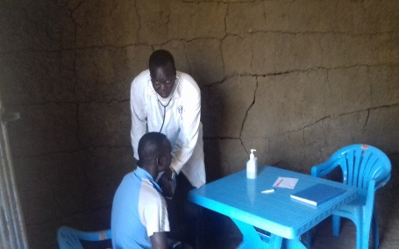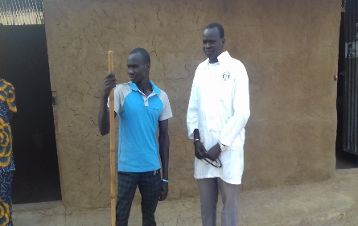
Marital status: Married
Occupation: Business
Location: Majak Boma

I live in Majak Boma, Kol Payam of Panyijiar County, Unity state. Before AFAA mobile outreach intervention in the area, I used not to go for medical treatment in Nyal when I feel sick because of the distance and movement in water due to my disability, but now since the health service are brought closer to us, am attending my medical treatment whenever am sick easily within majak without going to Nyal for medical service which is one and half hour walk from Majak to Nyal health facility
Before coming of AFAA mobile program to Majak, I lost my boy due to lack of medical service in Majak. We try to take the boy to Nyal PHCC for treatment but the boy did not reached the health facility because of the distance and the level of water was very high with no canoe during that time because it was mid night.
I give thanks to AFAA as organization and to the staffs who are delivering health service to us. I will pray to God for those staffs who are helping us to remain healthy and do better to our community and also big thanks to Vitol and segal family foundations their support.

Name: Mading Kuol Nyak 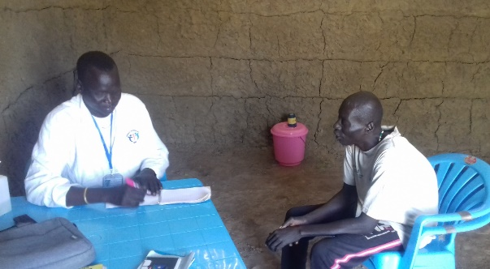
Age: 47 years
Sex: Male
Address: Tholoka

I was very sick from malaria when I came here for the first time and the AFAA clinical officer provide me medical treatment where I got improvement. Now I thank AFAA for saving my life from malaria. I appreciated the work AFAA is doing and also asking them to do more for this community because without AFAA mobile team, I would have lost my life from malaria but since AFAA is here with their health service many lives have been save here in Majak.
I give thanks to AFAA as organization and to the staffs who are delivering health service to us. I will pray to God for those staffs who are helping us to remain healthy and do better to our community and also big thanks to Vitol and segal family foundations.

